



**جامعة الحسين التقنية**

**Al Hussein Technical University**

**Project Title**

**Instagram website testing**

**The instructor**

**Eng. Samah Atef**

**Trainee Name : BAHA-AD-DIN AKOUR**

**Course : Quality assurance**

**May – 2023**

**List of Content**

**CHAPTER ONE:** **TEST PLAN**

* 1. Introduction……………………………………………………………………………………1
  2. Scope…………………………………………………………………………………………..1
  3. Test Objectives………………………………………………………………………………...2
  4. Test types…………………………………………………………………………………...…3
  5. Time estimation…………………………………………………………………………….…4
  6. Pass/Fail criteria……………………………………………………………………………….5
  7. Environment…………………………………………………………………………………...6
  8. Exist criteria………………………………………………………………………………...…7

**CHAPTER TWO:** **TEST CASES**

* 1. Introduction……………………………………………………………………………………7
  2. Test Cases for Instagram website:……..……………………………………………………...7

**CHAPTER THREE: BUG REPORTS**

Enhancement ………………………………………………………………………….……...….38

Defect…………………………………………………………………………………………….41

**CHAPTER FOUR: TEST SUMMARY REPORTS**

4.1 Project Overview……………………………………………………………………………49

4.2 Objective……………………………………………………………………………………49

4.3 Statistics of the test cases……………………………………………………………………50.

4.4 Statistics of the bugs…………………………………………………………………………53

4.5 Graph the metrics……………………………………………………………………………53

**CHAPTER FIVE:** **CONCLUSION**

Conclusion………………………………………………………………………………………54

References………………………………………………………………………………………55

**CHAPTER ONE: TEST PLAN**

* 1. Introduction

The Instagram website is one of the most popular social media platforms in the world, with millions of users logging in every day to share their photos and stories. As part of the quality assurance project, I have conducted testing on the website to ensure that it meets the standards of performance and user experience.

The Test Plan was written to explain the testing methodology. It comprises the goals, scope, timetable, and approach. What the test deliverables will be and what is considered in and out of scope will be made explicit in this document.

1.2 Scope

1.2.1 In of Scope:

The initial phase will include all ‘must have’ requirements. These and any other requirements that are included must all be tested.

At the end of Phase 1, a tester must be able to [1]:

1. Create a manual test with as many steps as necessary.
2. Save it.
3. Retrieve it and can view it when running the test.
4. Enter results and appropriate comments.
5. View results

Scenario: The user is in the start state, where he opens the website and does the actions.

The first action is to create an account, or if he has an account, he will login.

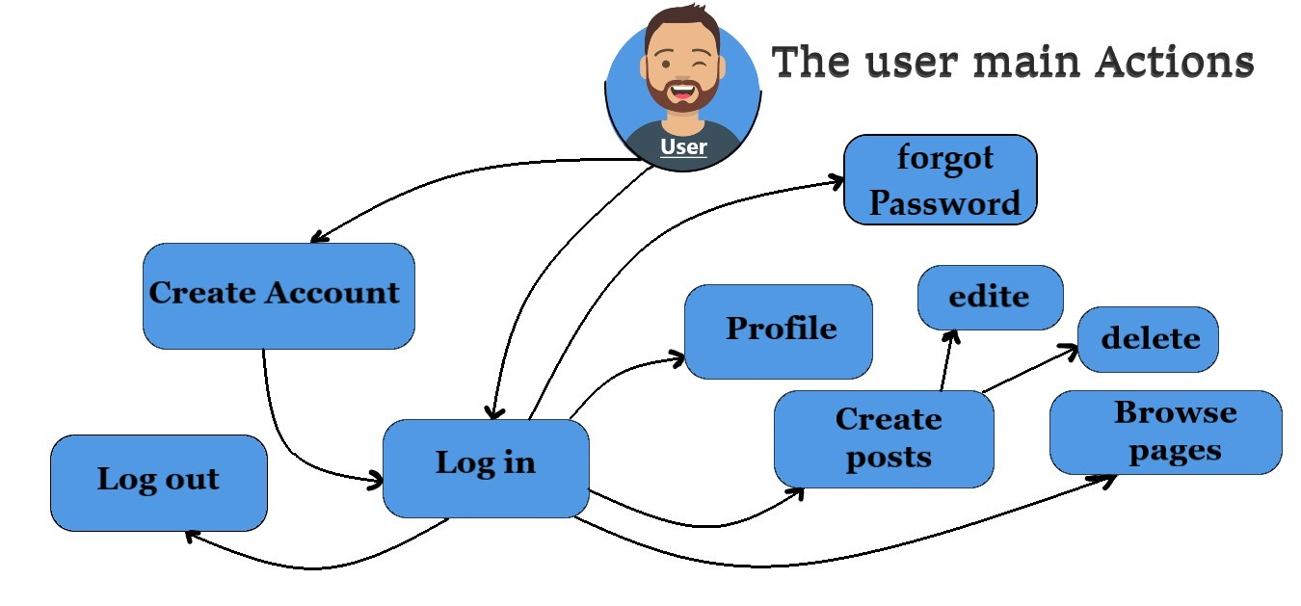

Image (1-1): The user main Actions

In Image (1-1), you see the main action a user can take on a website.

As I work with the project, I will define the needs for the second phase.

I will test main pages in website Instagram, where user using constantly:

* Sing Up.
* Login.
* Forgot password.
* User profile: manage, edit, add post, remove post, edit post.
* Follow another page.
* Browsing posts page.
* Two languages pages: Arabic and EN.
* Logout.

The pages that will be tested according to their importance to a user.

1.2.2 Out of Scope:

Load testing will not be considered part of this project since the user base is known and not an issue. Performance testing will not be considered part of this project because we lack the authority to access the system, identify the users who have logged in, and raise the load to observe the performance, we can only learn about the performance as regular users [1].

The rest of the pages were not tested:

* the settings page.
* some links at the bottom of the page
* the Reels page.
* the help pages.
* and other language pages I will test two languages only
* Anther details.

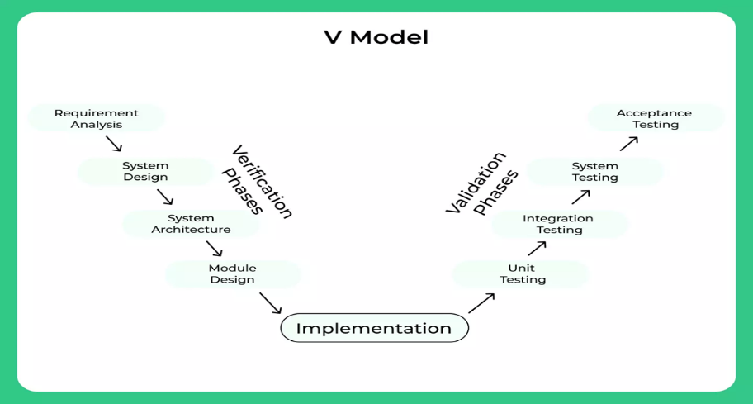The model: The V-model is an SDLC model where execution of processes happens in a sequential manner in a V-shape. It is also known as Verification and Validation model. The V-Model is an extension of the waterfall model and is based on the association of a testing phase for each corresponding development stage.

1.3 Test Objectives

* Verify the core functionality of the Instagram web site.
* Assess the responsiveness of the web application [3].
* Evaluate the usability.
* Verify the web app’s localization support.
* Perform regression testing to ensure existing features and not affected by new updates.

Phase 1 of the project will deliver TCT (Test Case Template) with functionality to create and store manual tests [1].

According to the pesticide paradox, if the same test cases are repeatedly run, ultimately, they will stop revealing any new flaws in the system. It is necessary to continuously evaluate and change the test cases to resolve this "pesticide paradox."[2]

I will test the main pages for the web site Instagram and create an account and make sure all pages are fine and logical. If some cases do not work (bugs) I will write bug report and use the software to add the bug report for pesticide.

1.4 Testing types.

* Functional Testing:
  + Account creation and login/logout functionality.
  + Photo uploading and posting.
  + Direct messaging and notifications.
  + Explore/search functionality.
* Usability Testing:
  + Evaluate app navigation, UI design, and intuitiveness.
  + Assess the ease of use and accessibility features.
* Security and Privacy Testing:
  + Test authentication mechanisms.
* Localization Testing:
  + Test language translations and locale-specific elements.
* Compatibility Testing:
  + Ensure compatibility with camera apps, image editors, and posting options.
  + Ensuring the system functions correctly across different platforms, browsers.
  + Verifying the system's compatibility with various web browsers.
* Regression Testing:
  + Re-test previously tested features to identify regressions.
* Maintainability Testing:
  + Evaluating the system's ease of maintenance, including updates, bug fixes, and enhancements.

1.5 Time estimation.

Time estimation is the limit of time to do tasks.

example of time estimation for test planning, test case creation, bug reporting, and test summary reports:

1. Test Planning:

For a medium-sized web application project, the test planning phase may take approximately 3-5% of the total project duration. For example, if the project is estimated to take 4 weeks, the test planning phase might be allocated 1-3 days.[5]

1. Test Case Creation:

Assuming the web application has 100 key features to be tested, and on average, it takes 30 minutes to create a test case for each feature, the estimated time for test case creation would be around 50 hours (100 features * 0.5 hours per feature).[5]

1. Bug Reports:

During the testing phase, let's assume that 50 bugs were identified. Assuming it takes 15 minutes to create a bug report for each issue, the estimated time for bug reporting would be approximately 12.5 hours (50 bugs * 0.25 hours per bug).[5]

1. Test Summary Reports:

Upon completion of testing, generating a test summary report may require around 1-2% of the total project duration. For example, if the project is estimated to take 4 weeks, the time allocated for test summary reports would be 5-10 hours.[5]

How I will be dividing the tasks, in table (1-1) you can see how I divide the Time line for do the test tasks.

**Timeline**:

|  |  |
| --- | --- |
| **Days** | **Task** |
| **1 - 3** | Test planning |
| **4 - 9** | Test cases |
| **10 - 13** | Bug reports |
| **12 - 15** | Test summary reports |

Table (1-1): The project Tasks

1.6 Pass/Fail criteria.

The following factors can be used to decide if the testing activities passed or failed:

1. Functional testing is required, and the desired behavior must match or be very similar to the tested behavior for each individual function. The test case will fail if there is any illogical divergence from the intended behavior.
2. Testing for Compatibility: The website should work properly on the operating systems and web browsers listed. A test would fail if a significant component on a certain platform did not perform as expected.
3. Navigation and UI Testing: The website's navigation should be simple and easy to use. A test would be deemed unsuccessful if users had trouble locating or using features.

1.7 Environment.

The testing environment for Instagram website testing would include:

* Operating Systems: Windows.
* Web Browsers: Google Chrome, Mozilla Firefox, Microsoft Edge, and old browser Internet explorer.
* Screen Responsive: a webpage's element placement when the browser is resized.
* Test Data: create some account to test it.
  1. Exist criteria.

When to stop testing

Exit criteria is defined during test planning stage.

Typical test exit criteria:

* All identified Test cases were executed.
* No critical and major bugs open.

Prioritize testing so that whenever you stop testing, you have done the best testing in the time available.

**CHAPTER TWO: TEST CASES**

**2.1 Introduction**

The testing process is not complete without test cases, which are critical to the integrity and effectiveness of the Instagram website. They offer a methodical process for validating various features, functionality, and user interactions.

**2.2 Test Cases for Instagram web site:**

System Integration Testing or SIT is done by testers.

**2.2.1 The User will be creating the Account:**

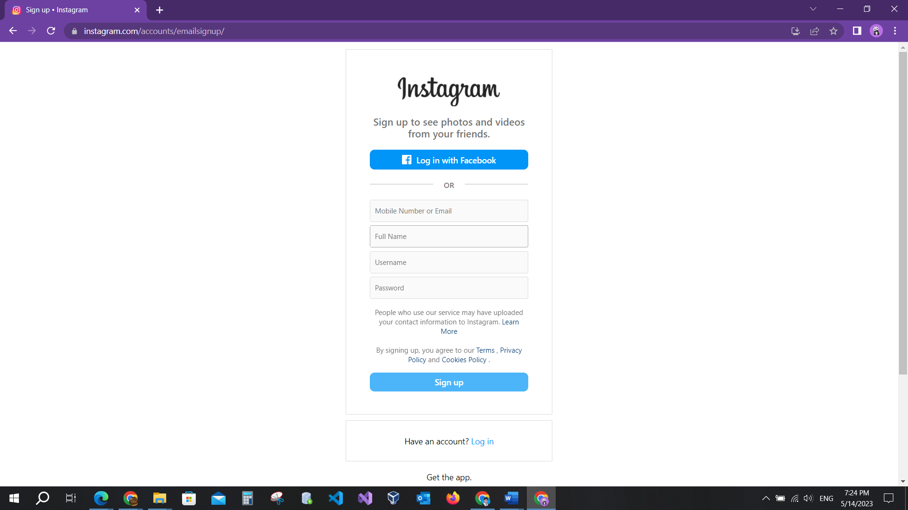

Image (2-1): Sign up page.

Image (2-1) shows the signup page where I will write and execute test cases.

SIT - Sign up page.

Service Description: Test the sign-up page for Instagram website.

Document Revision History

|  |  |  |  |
| --- | --- | --- | --- |
| Version # | Revision Date | Originator | Revision |
| V300.1 | 13.5.2023 | BAHA-AD-DIN AKOUR | BAHA-AD-DIN AKOUR |

Table (2-1): Revision History.

In this table, you will see the version of the project and the revision history where the originator added the test cases and how they were revised. In this project, I will organize and revise the test cases, and whoever revises after me will edit his name in the revision. On the website, I don’t find the version information, but on iOS and Android, this information is known.

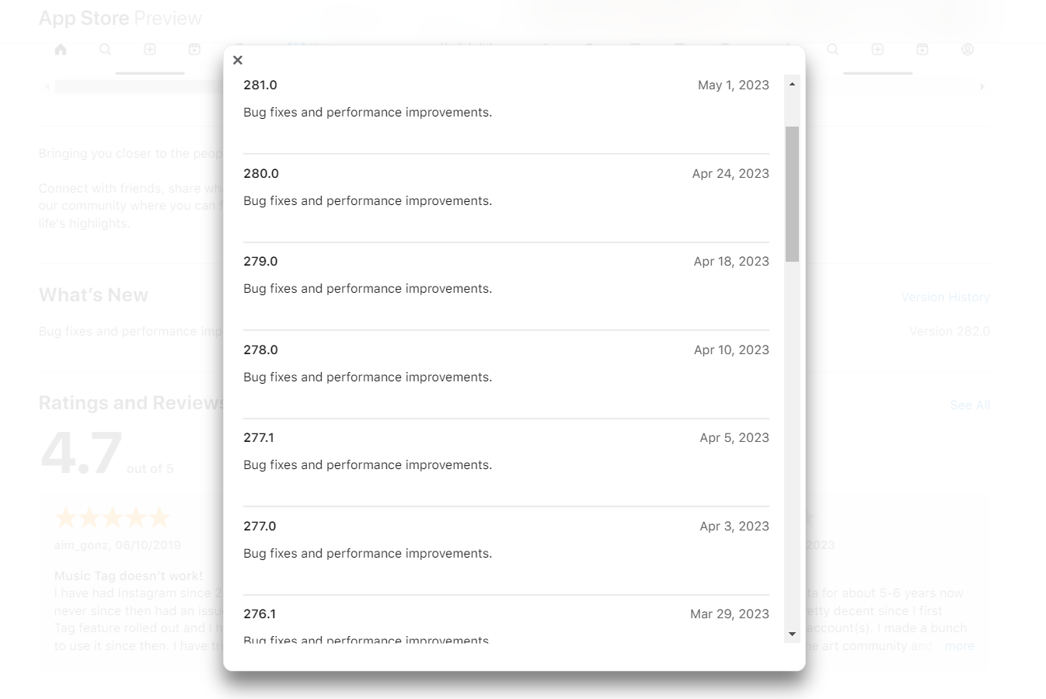

Image (2-2): the Version information

In Image (2-2), you see the versions for the ISO application history for "bug fixes and performance improvements". Based on the information about Apple applications, I noticed that there are two to six updates every month.

I noticed the meta company focused on mobile Instagram apps in terms of design and functionality.

**Test cases Tables for Sign up page:**

|  |  |  |
| --- | --- | --- |
| Test Case ID | 001 | |
| Test Case title | The user has profile in Facebook | |
| Test Case summary | Check button | |
| Test Steps | 1. Open the website link https://www.instagram.com/. 2. Click on Sign Up. 3. Click on the button “Login in with Facebook”. 4. Redirect to Facebook login page. 5. Login his account | |
| Results | Expected | Go to another information to create the account |
| Actual result | The user can create the user from facebook |
| Notes/Comments | The user already has Facebook profile. | |

|  |  |  |
| --- | --- | --- |
| Test Case ID | 002 | |
| Test Case title | User clicks Instagram logo to go the main page. | |
| Test Case summary | Check logo link | |
| Test Steps | 1. Open the website link https://www.instagram.com/. 2. Click on Sign Up. 3. Click on the image “Instagram”. 4. Redirect to Instagram main page. | |
| Results | Expected | Go to the main page www.instagram.com |
| Actual result | Not go to main page |
| Notes/Comments | The user wants to go to main page | |

|  |  |  |
| --- | --- | --- |
| Test Case ID | 003 | |
| Test Case tile | The user fills all fields valid (happy case) | |
| Test Case summary | Check required fields | |
| Test Steps | 1. Open the website link https://www.instagram.com/. 2. Click on Sign Up. 3. Fill valid mobile number or valid Email, valid username and valid password. 4. Click on Sing up button. | |
| Results | Expected | Account is created |
| Actual | Account is created |
| Notes/Comments | User has mobile number or email | |

|  |  |  |
| --- | --- | --- |
| Test Case ID | 004 | |
| Test Case title | The user fills not valid mobile number | |
| Test Case summary | Check required fields | |
| Test Steps | 1. Open the website link https://www.instagram.com/. 2. Click on Sign Up. 3. Fill not valid mobile number, valid username, and valid password. 4. Click on Sing up button. | |
| Results | Expected | Error message indicates it |
| Actual | Entered to next page |
| Notes/Comments |  | |

|  |  |  |
| --- | --- | --- |
| Test Case ID | 005 | |
| Test Case title | The user fills not valid email | |
| Test Case summary | Check required fields | |
| Test Steps | 1. Open the website link https://www.instagram.com/. 2. Click on Sign Up. 3. Fill not valid email, valid username, and valid password. 4. Click on Sing up button. | |
| Results | Expected | Error message indicates it |
| Actual | Entered to next page |
| Notes/Comments |  | |

|  |  |  |
| --- | --- | --- |
| Test Case ID | 006 | |
| Test Case title | The user fills not valid Full Name special characters only | |
| Test Case summary | Check required fields | |
| Test Steps | 1. Open the website link https://www.instagram.com/. 2. Click on Sign Up. 3. Fill number, full name characters only, valid username, and valid password. 4. Click on Sing up button. | |
| Results | Expected | Error message indicates it |
| Actual | Entered to next page and account created |
| Notes/Comments | Special characters only it is not valid or not logically name.  Special characters: () *&$@! /+->..... | |

|  |  |  |
| --- | --- | --- |
| Test Case ID | 007 | |
| Test Case title | The user fills not valid Full Name number only | |
| Test Case summary | Check required fields | |
| Test Steps | 1. Open the website link https://www.instagram.com/. 2. Click on Sign Up. 3. Fill number, full name numbers only, valid username, and valid password. 4. Click on Sing up button. | |
| Results | Expected | Error message indicates it |
| Actual | Entered to next page and account created |
| Notes/Comments | Full name not valid because the name has maxed the character and number, but number only not valid. | |

|  |  |  |
| --- | --- | --- |
| Test Case ID | 008 | |
| Test Case title | The user fills valid username, but username reserved | |
| Test Case summary | Check required fields | |
| Test Steps | 1. Open the website link https://www.instagram.com/. 2. Click on Sign Up. 3. Fill number, valid full name, valid username, and valid password. 4. Click on Sing up button. | |
| Results | Expected | Error message indicates it |
| Actual | Error icon |
| Notes/Comments | Special characters: () *&$@! /+->..... | |

|  |  |  |
| --- | --- | --- |
| Test Case ID | 009 | |
| Test Case title | The user fill not valid username using special character only | |
| Test Case summary | Check required fields | |
| Test Steps | 1. Open the website link https://www.instagram.com/. 2. Click on Sign Up. 3. Fill number, valid full name, not valid username, and valid password. 4. Click on Sing up button. | |
| Results | Expected | Error message indicates it |
| Actual | Error icon |
| Notes/Comments | Special characters: () *&$@! /+->..... | |

|  |  |  |
| --- | --- | --- |
| Test Case ID | 010 | |
| Test Case title | The user fills not valid username using numbers only | |
| Test Case summary | Check required fields | |
| Test Steps | 1. Open the website link https://www.instagram.com/. 2. Click on Sign Up. 3. Fill number, valid full name, not valid username, and valid password. 4. Click on Sing up button. | |
| Results | Expected | Error message indicates it |
| Actual | Error icon |
| Notes/Comments |  | |

|  |  |  |
| --- | --- | --- |
| Test Case ID | 011 | |
| Test Case title | The user fills not stronger password using numbers only | |
| Test Case summary | Check required fields | |
| Test Steps | 1. Open the website link https://www.instagram.com/. 2. Click on Sign Up. 3. Fill number, valid full name, not valid username, and valid password. 4. Click on Sing up button. | |
| Results | Expected | Msg rewrite the password, Hint (use mix between the capital latter and small and number and special character) |
| Actual | Entered to next page and account created |
| Notes/Comments |  | |

|  |  |  |
| --- | --- | --- |
| Test Case ID | 012 | |
| Test Case title | The user fills not stronger password using special character only | |
| Test Case summary | Check required fields | |
| Test Steps | 1. Open the website link https://www.instagram.com/. 2. Click on Sign Up. 3. Fill number, valid full name, not valid username, and valid password. 4. Click on Sing up button. | |
| Results | Expected | Msg rewrite the password, Hint (use mix between the capital letter and small and number and special character) |
| Actual | Entered to next page and account created |
| Notes/Comments |  | |

|  |  |  |
| --- | --- | --- |
| Test Case ID | 013 | |
| Test Case title | The user fills not stronger password using English capital latter only | |
| Test Case summary | Check required fields | |
| Test Steps | 1. Open the website link https://www.instagram.com/. 2. Click on Sign Up. 3. Fill number, not valid username, and valid password. 4. Click on Sing up button. | |
| Results | Expected | Msg rewrite the password, Hint (use mix between the capital letter and small and number and special character) |
| Actual | Entered to next page and account created |
| Notes/Comments |  | |

|  |  |  |
| --- | --- | --- |
| Test Case ID | 014 | |
| Test Case title | The user fills not stronger password using English small latter only | |
| Test Case summary | Check required fields | |
| Test Steps | 1. Open the website link https://www.instagram.com/. 2. Click on Sign Up. 3. Fill number, not valid username, and valid password. 4. Click on Sing up button. | |
| Results | Expected | Msg rewrite the password, Hint (use mix between the capital letter and small and numbers and special character) |
| Actual | Entered to next page and account created |
| Notes/Comments |  | |

|  |  |  |
| --- | --- | --- |
| Test Case ID | 015 | |
| Test Case title | The user fills password using Arabic latter | |
| Test Case summary | Check required fields | |
| Test Steps | 1. Open the website link https://www.instagram.com/. 2. Click on Sign Up. 3. Fill number or email, not valid username, and valid password. 4. Click on Sing up button. | |
| Results | Expected | Msg rewrite the password, Hint (use mix between the capital letter and small letter in English and number and special character) |
| Actual | Entered to next page but not account created |
| Notes/Comments |  | |

|  |  |  |
| --- | --- | --- |
| Test Case ID | 016 | |
| Test Case title | The user doesn’t fill the fields (empty) | |
| Test Case summary | Check required fields | |
| Test Steps | 1. Open the website link https://www.instagram.com/. 2. Click on Sign Up. 3. Not fill any failed. 4. Click on Sing up button. | |
| Results | Expected | Error Msg or not active |
| Actual | Not active Sing up button |
| Notes/Comments |  | |

|  |  |  |
| --- | --- | --- |
| Test Case ID | 017 | |
| Test Case title | The user remembers account and go back to login page from link in the page | |
| Test Case summary | Check login link | |
| Test Steps | 1. Open the website link https://www.instagram.com/. 2. Click on Sign Up. 3. Opened Sing up page. 4. Click on “Login” link. | |
| Results | Expected | Go back to login |
| Actual | Go back to login |
| Notes/Comments |  | |

|  |  |  |
| --- | --- | --- |
| Test Case ID | 018 | |
| Test Case title | The user remembers account and go back to login page from browser back button. | |
| Test Case summary | Check ‘go back’ | |
| Test Steps | 1. Open the website link https://www.instagram.com/. 2. Click on Sign Up. 3. Opened Sing up page. 4. Click on browser back button. | |
| Results | Expected | Go back to login |
| Actual | Go back but the form save sing up |
| Notes/Comments |  | |

**2.2.2 The user will be log in with an account:**

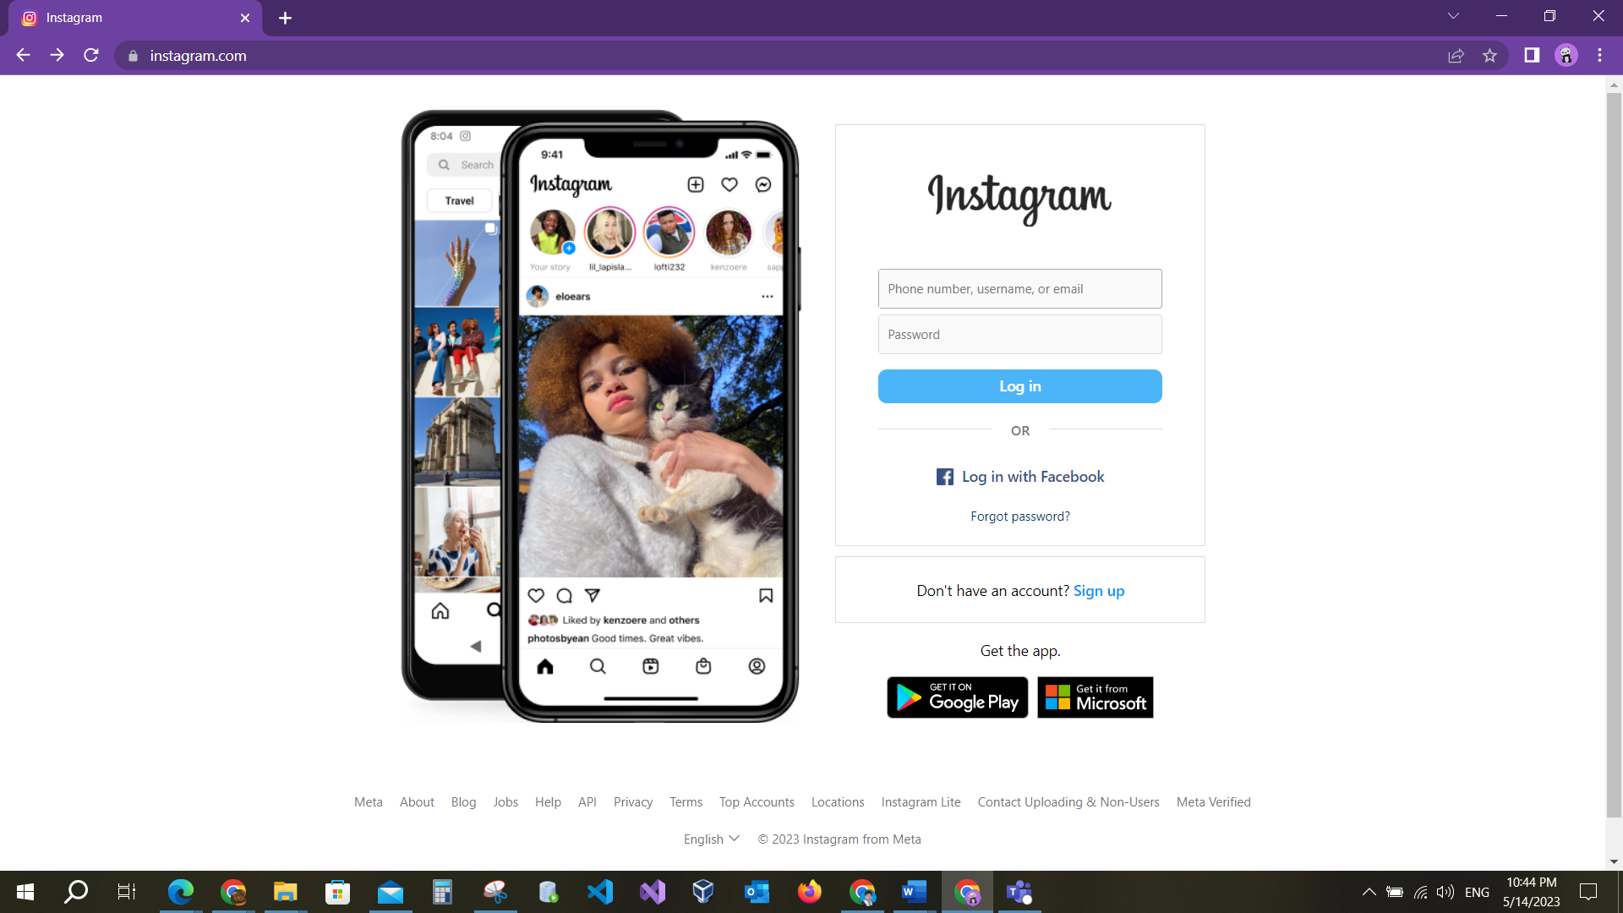

Image (2-3): Login page

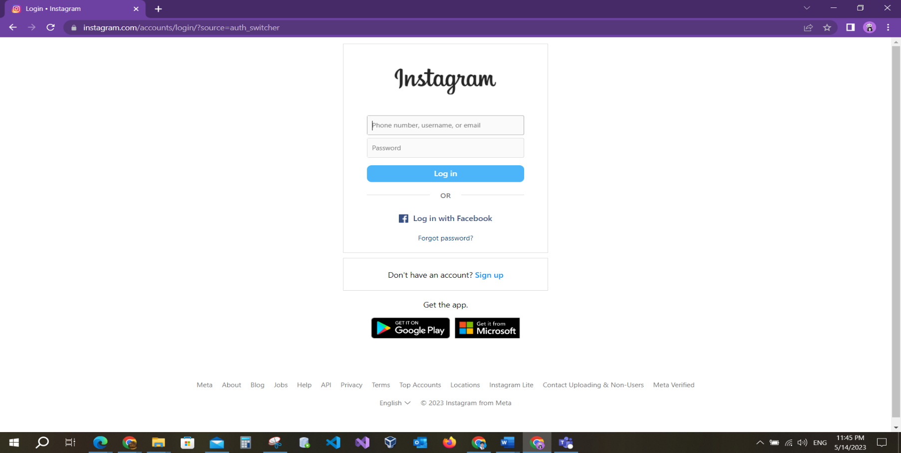

Image (2-4): The second page for Login

Image (2-4), It is the second page for logging in from the login link on the sign-up page. It has the same test cases. Image (2-3) shows the main login page.

SIT – Login page.

Service Description: Test the Login page for Instagram website.

Test cases Table for Login:

|  |  |  |
| --- | --- | --- |
| Test Case ID | 001 | |
| Test Case title | The user fills all fields valid (happy case) | |
| Test Case summary | Check required fields | |
| Test Steps | 1. Open the website link https://www.instagram.com/. 2. Fill valid Phone number or email or username and password. 3. Click on Login button. | |
| Results | Expected | Entered to account |
| Actual | Entered to account if user entered the username |
| Notes/Comments | Only if you enter the username correct but phone or full name not entered | |

|  |  |  |
| --- | --- | --- |
| Test Case ID | 002 | |
| Test Case title | The user fills not valid number and valid password | |
| Test Case summary | Check required fields | |
| Test Steps | 1. Open the website link https://www.instagram.com/. 2. Fill valid Phone number or email or username and password. 3. Click on Login button. | |
| Results | Expected | Not entered to account, display error message indicates it |
| Actual | Not entered to account, display error message |
| Notes/Comments |  | |

|  |  |  |
| --- | --- | --- |
| Test Case ID | 003 | |
| Test Case title | The user fills not valid username and valid password | |
| Test Case summary | Check required fields | |
| Test Steps | 1. Open the website link https://www.instagram.com/. 2. Fill valid Phone number or email or username and password. 3. Click on Login button. | |
| Results | Expected | Not entered to account, display error message indicates it |
| Actual | Not entered to account, display error message |
| Notes/Comments |  | |

|  |  |  |
| --- | --- | --- |
| Test Case ID | 004 | |
| Test Case title | The user fills not valid email and valid password | |
| Test Case summary | Check required fields | |
| Test Steps | 1. Open the website link https://www.instagram.com/. 2. Fill valid Phone number or email or username and password. 3. Click on Login button. | |
| Results | Expected | Not entered to account, display error message indicates it |
| Actual | Not entered to account, display error message |
| Notes/Comments |  | |

|  |  |  |
| --- | --- | --- |
| Test Case ID | 005 | |
| Test Case title | The user fills valid number and not valid password | |
| Test Case summary | Check required fields | |
| Test Steps | 1. Open the website link https://www.instagram.com/. 2. Fill valid Phone number or email or username and password. 3. Click on Login button. | |
| Results | Expected | Not entered to account, display error message indicates it |
| Actual | Not entered to account, display error message |
| Notes/Comments |  | |

|  |  |  |
| --- | --- | --- |
| Test Case ID | 006 | |
| Test Case title | The user fills valid username and not valid password | |
| Test Case summary | Check required fields | |
| Test Steps | 1. Open the website link https://www.instagram.com/. 2. Fill valid Phone number or email or username and password. 3. Click on Login button. | |
| Results | Expected | Not entered to account, display error message indicates it |
| Actual | Not entered to account, display error message |
| Notes/Comments |  | |

|  |  |  |
| --- | --- | --- |
| Test Case ID | 007 | |
| Test Case title | The user fills valid email and not valid password | |
| Test Case summary | Check required fields | |
| Test Steps | 1. Open the website link https://www.instagram.com/. 2. Fill valid Phone number or email or username and password. 3. Click on Login button. | |
| Results | Expected | Not entered to account, display error message indicates it |
| Actual | Not entered to account, display error message |
| Notes/Comments |  | |

|  |  |  |
| --- | --- | --- |
| Test Case ID | 008 | |
| Test Case title | The user direct login without fill. | |
| Test Case summary | Check required fields | |
| Test Steps | 1. Open the website link https://www.instagram.com/. 2. Click on Login button. | |
| Results | Expected | Not entered to account, display error message indicates it |
| Actual | Not active login button |
| Notes/Comments |  | |

|  |  |  |
| --- | --- | --- |
| Test Case ID | 010 | |
| Test Case title | The user forgot password | |
| Test Case summary | Check Link | |
| Test Steps | 1. Open the website link https://www.instagram.com/. 2. Click on “forgot password?” . | |
| Results | Expected | Opened the forgot password page |
| Actual | Opened the forgot password page |
| Notes/Comments |  | |

|  |  |  |
| --- | --- | --- |
| Test Case ID | 011 | |
| Test Case title | The user does not have an account. | |
| Test Case summary | Check link | |
| Test Steps | 1. Open the website link https://www.instagram.com/. 2. Click on “Sign up.” | |
| Results | Expected | Opened the Sign-up page |
| Actual | Opened the Sign-up page |
| Notes/Comments |  | |

**2.2.3 The user forgot his password:**

SIT – Forgot page.

Service Description: Test the Forgot page for Instagram website.

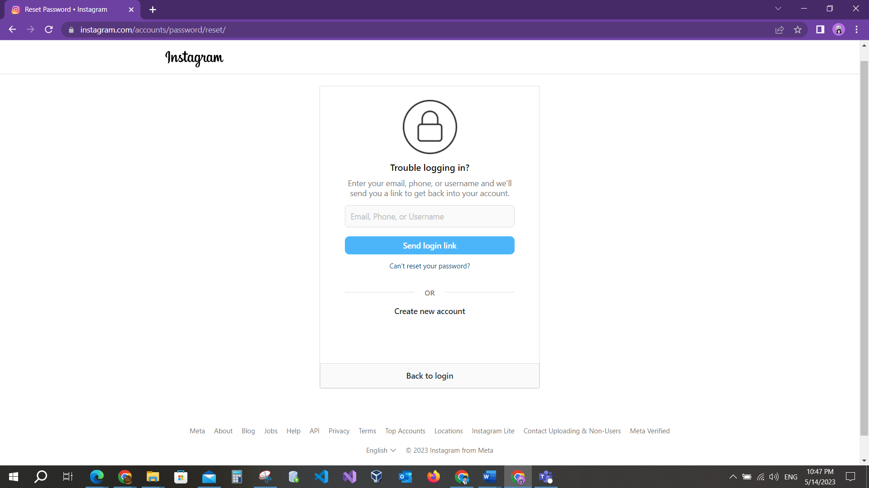

Image (2-5): forgot password page.

Image (2-5) shows the forgotten password page. If the user forgets his password, he will open it.

Test cases Tables for forgot password page:

|  |  |  |
| --- | --- | --- |
| Test Case ID | 001 | |
| Test Case title | The user fills valid phone number | |
| Test Case summary | Check required fields | |
| Test Steps | 1. Open the website link https://www.instagram.com/. 2. Click on “forgot password?” 3. Fill in the field valid phone number. 4. Click on “Send login link” button | |
| Results | Expected | Send the message of authentication to your phone number and redirect to the next page to enter the authentication number. |
| Actual | Msg not send to phone number |

|  |  |  |
| --- | --- | --- |
| Test Case ID | 002 | |
| Test Case title | The user fills valid username | |
| Test Case summary | Check required fields | |
| Test Steps | 1. Open the website link https://www.instagram.com/. 2. Click on “forgot password?” 3. Fill in the field valid username. 4. Click on “Send login link” button | |
| Results | Expected | Send the message of authentication to your email or Phone number and redirect to the next page to enter the authentication number. |
| Actual | Send msg to email only |
| Notes/Comments |  | |

|  |  |  |
| --- | --- | --- |
| Test Case ID | 003 | |
| Test Case title | The user fills valid email. | |
| Test Case summary | Check required fields | |
| Test Steps | 1. Open the website link https://www.instagram.com/. 2. Click on “forgot password?” 3. Fill in the field valid email. 4. Click on “Send login link” button | |
| Results | Expected | Send the message of authentication to your email and redirect to the next page to enter the authentication number. |
| Actual | Send the message to email |

|  |  |  |
| --- | --- | --- |
| Test Case ID | 004 | |
| Test Case title | The user fills not valid phone number. | |
| Test Case summary | Check required fields | |
| Test Steps | 1. Open the website link https://www.instagram.com/. 2. Click on “forgot password?” 3. Fill in the field not valid phone number. 4. Click on “Send login link” button | |
| Results | Expected | Error message indicates it |
| Actual | Error message “not found user” |
| Notes/Comments |  | |

|  |  |  |
| --- | --- | --- |
| Test Case ID | 005 | |
| Test Case title | The user fills not valid username. | |
| Test Case summary | Check required fields | |
| Test Steps | 1. Open the website link https://www.instagram.com/. 2. Click on “forgot password?” 3. Fill in the field valid phone number. 4. Click on “Send login link” button | |
| Results | Expected | Error message indicates it |
| Actual | Error message “not found user” |
| Notes/Comments |  | |

|  |  |  |
| --- | --- | --- |
| Test Case ID | 006 | |
| Test Case title | The user fills not valid email. | |
| Test Case summary | Check required fields | |
| Test Steps | 1. Open the website link https://www.instagram.com/. 2. Click on “forgot password?” 3. Fill in the field not valid email. 4. Click on “Send login link” button | |
| Results | Expected | Error message indicates it |
| Actual | Error message “not found user” |

**2.2.4 The user browses the home page:**

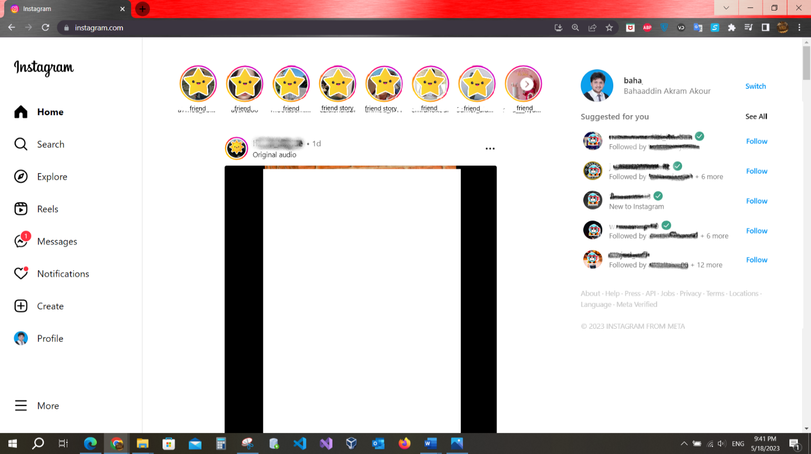

Image (2-6): the home page

Now, you see the main page "instagram.com" change when the user logins with an account and is redirected to the home page. The first main page is the login page.

SIT – Home page.

Service Description: Test the Home page for Instagram website.

|  |  |  |
| --- | --- | --- |
| Test Case ID | 001 | |
| Test Case title | The user scrolls down to see the posts. | |
| Test Case summary | Check the Scroll down | |
| Test Steps | 1. Open the website link https://www.instagram.com/. 2. Ensure that the page opened is home page. 3. Scroll down to show the posts. | |
| Results | Expected | Scrolled down and see posts |
| Actual | Scrolled down and see posts |
| Notes/Comments |  | |

|  |  |  |
| --- | --- | --- |
| Test Case ID | 002 | |
| Test Case title | The user clicks on followers’ stories and browses them. | |
| Test Case summary | Check the stories section. | |
| Test Steps | 1. Open the website link https://www.instagram.com/. 2. Ensure that the page opened is home page. 3. Click on the stories section. | |
| Results | Expected | Browsed the stories |
| Actual | Browsed the stories |

|  |  |  |
| --- | --- | --- |
| Test Case ID | 003 | |
| Test Case title | the user can follow another account in “suggested for you” section | |
| Test Case summary | Check “suggested for you” section | |
| Test Steps | 1. Open the website link https://www.instagram.com/. 2. Ensure that the page opened is home page. 3. Click on the stories section | |
| Results | Expected | Followed another account |
| Actual | Followed anther account |
| Notes/Comments |  | |

|  |  |  |
| --- | --- | --- |
| Test Case ID | 004 | |
| Test Case title | the user clicks “See All” in suggested for you section | |
| Test Case summary | Check Link See all | |
| Test Steps | 1. Open the website link https://www.instagram.com/. 2. Ensure that the page opened is home page. 3. Click on See All in suggested for you section | |
| Results | Expected | Opened the suggested for you page |
| Actual | Opened the suggested for you page |
| Notes/Comments |  | |

|  |  |  |
| --- | --- | --- |
| Test Case ID | 005 | |
| Test Case title | the user clicks in his photo and name profile to open profile page. | |
| Test Case summary | Check photo and name element. | |
| Test Steps | 1. Open the website link https://www.instagram.com/. 2. Ensure that the page opened is home page. 3. Click on your photo and name profile. | |
| Results | Expected | Opened the profile page |
| Actual | Opened the profile page |
| Notes/Comments |  | |

|  |  |  |
| --- | --- | --- |
| Test Case ID | 006 | |
| Test Case title | the user Clicks in a “switch” to switch to another account | |
| Test Case summary | Check switch link | |
| Test Steps | 1. Open the website link https://www.instagram.com/. 2. Ensure that the page opened is home page. 3. Click on switch. | |
| Results | Expected | Show anther account to switched |
| Actual | Show anther account to switched |
| Notes/Comments |  | |

* + 1. **User profile**

SIT – User profile page.

Service Description: Test the Forgot page for Instagram website.

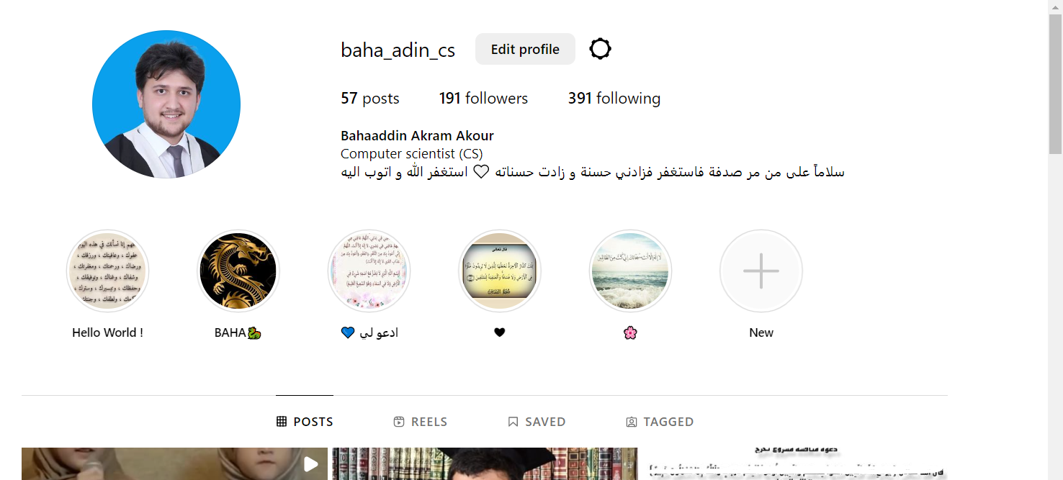

Image (2-7): The user profile

|  |  |  |
| --- | --- | --- |
| Test Case ID | 001 | |
| Test Case title | the user edits his profile. | |
| Test Case summary | Check button | |
| Test Steps | 1. Open the website link https://www.instagram.com/. 2. Open the profile page. 3. Click on Edit profile. | |
| Results | Expected | Edite option to edit |
| Actual | Show the option to edit the profile |
| Notes/Comments | You can edit name and some details | |

|  |  |  |
| --- | --- | --- |
| Test Case ID | 002 | |
| Test Case title | the user navigation to his reels or saved section or tagged | |
| Test Case summary | Check profile sections | |
| Test Steps | 1. Open the website link https://www.instagram.com/. 2. Open the profile page. 3. Navigate to (Reels, Saved, Tagged ). | |
| Results | Expected | Navigate to your post (post, reels, saved, tagged) |
| Actual | User navigates where he wants in his profile |
| Notes/Comments |  | |

|  |  |  |
| --- | --- | --- |
| Test Case ID | 003 | |
| Test Case title | the user pint his old story | |
| Test Case summary | Check “New” button in profile story section | |
| Test Steps | 1. Open the website link https://www.instagram.com/. 2. Open the profile page. 3. Click on “New” 4. Chose story you will show it in you profile | |
| Results | Expected | Added the story in his profile |
| Actual | Added the story in his profile |
| Notes/Comments |  | |

* + 1. **User can create , edit, delete the post:**

SIT – Forgot page.

Service Description: Test the post for Instagram website.

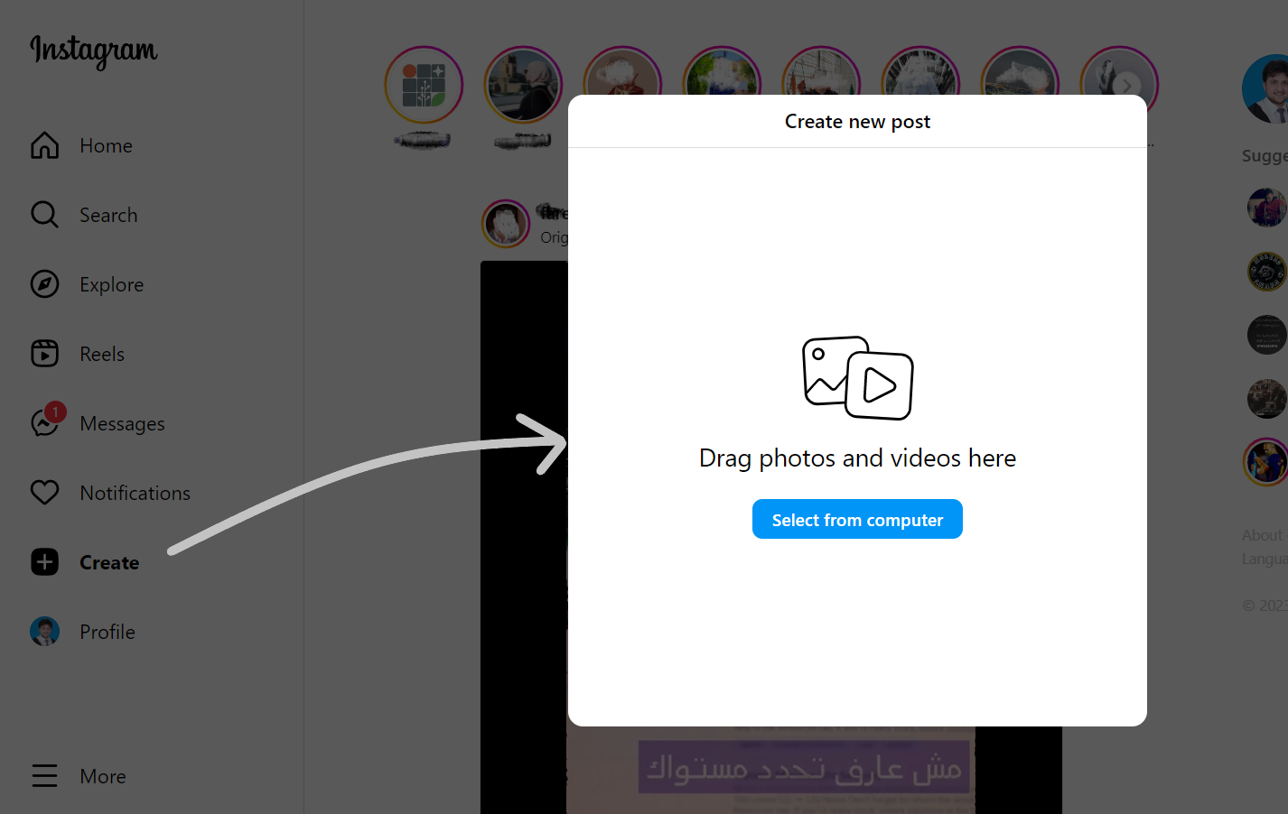

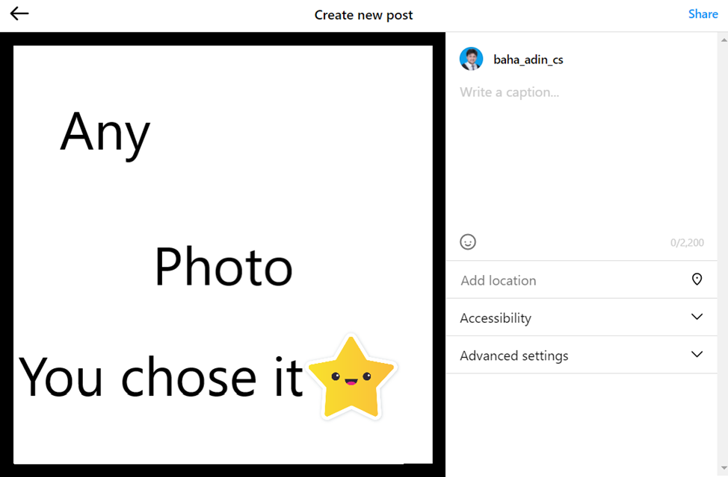

Image (2-7): Create new post.

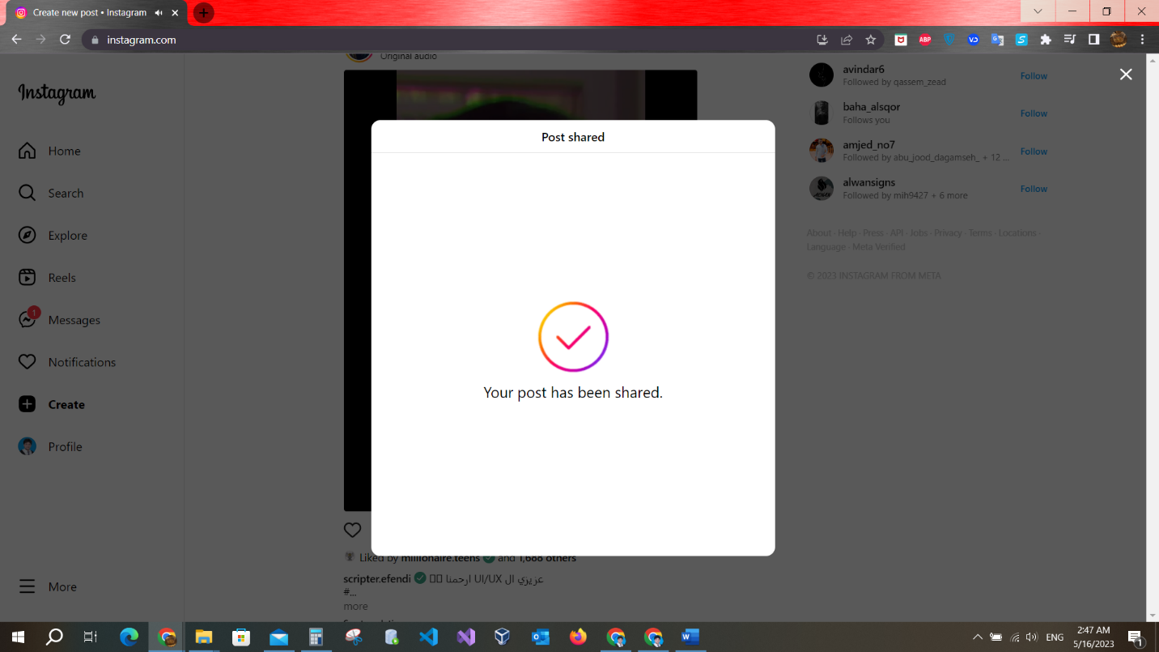

Image (2-8): the Post shared

|  |  |  |
| --- | --- | --- |
| Test Case ID | 001 | |
| Test Case title | the user creates the post videos or photos | |
| Test Case summary | Check Create post option | |
| Test Steps | 1. Open the website link https://www.instagram.com/. 2. Click on “Create”. 3. Click on “select from computer.” 4. Select any photo or video. 5. Next add details for the post 6. Click on share | |
| Results | Expected | Post created |
| Actual | Post created |
| Notes/Comments |  | |

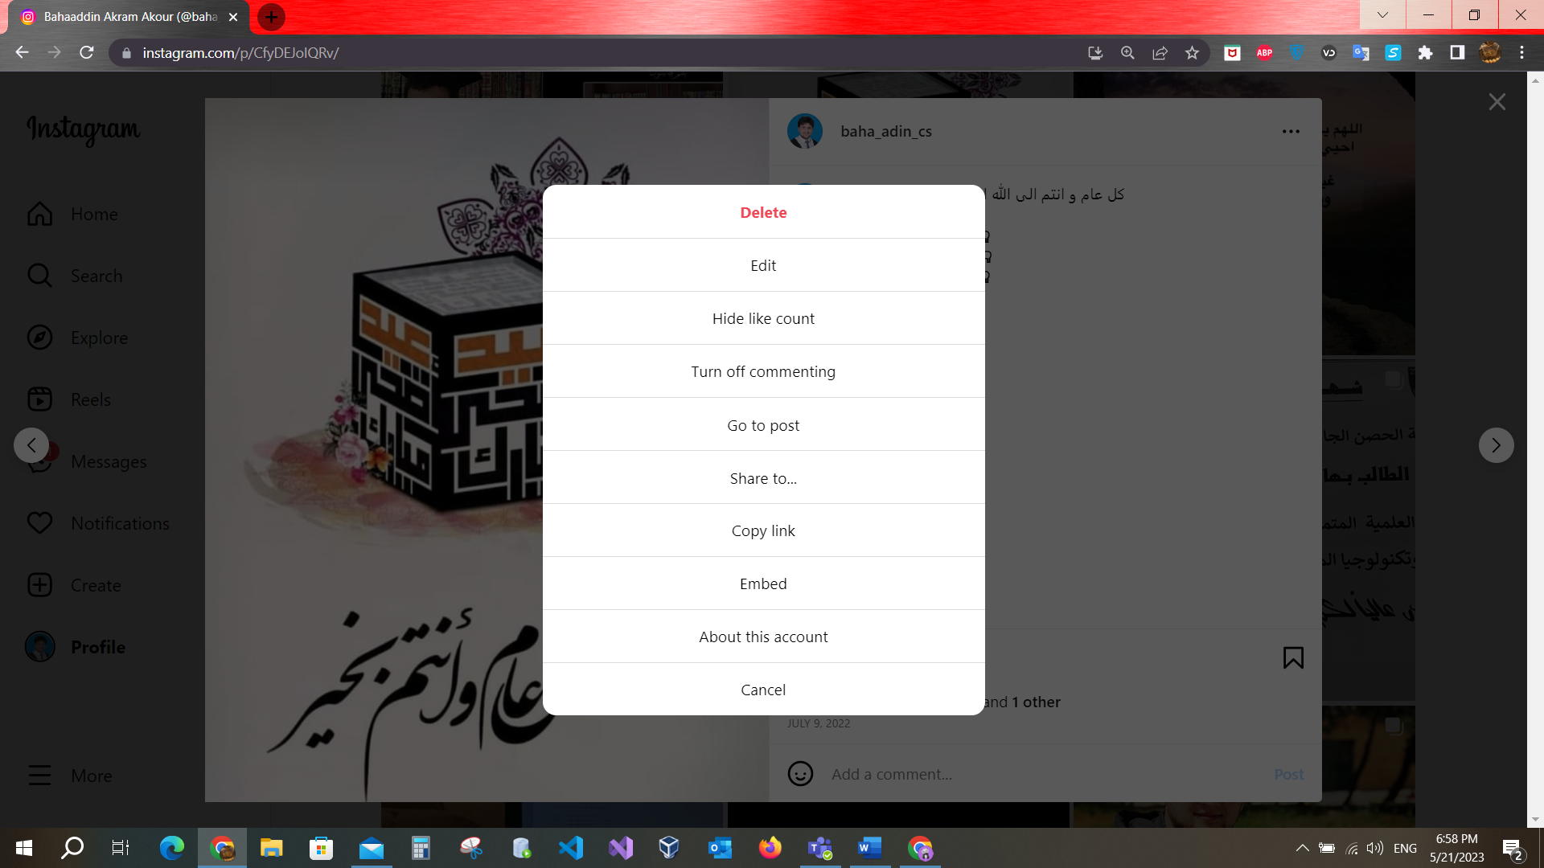



Image (2-9): the Post Options

|  |  |  |
| --- | --- | --- |
| Test Case ID | 002 | |
| Test Case title | the user edits on the post | |
| Test Case summary | Check edit post | |
| Test Steps | 1. Open the website link https://www.instagram.com/. 2. Click on “Create”. 3. Click on “select from computer.” 4. Select any photo or video. 5. Next add details for the post 6. Click on share. 7. Click on “…” 8. Click on “Edit” | |
| Results | Expected | Post can edit |
| Actual | Post can edit but the photo can’t |

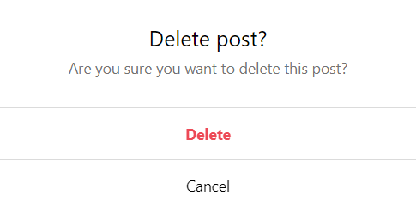

Image (2-9): the Post delete.

|  |  |  |
| --- | --- | --- |
| Test Case ID | 003 | |
| Test Case title | the user deletes the post | |
| Test Case summary | Check edit post | |
| Test Steps | 1. Open the website link https://www.instagram.com/. 2. Click on “Create”. 3. Click on “select from computer.” 4. Select any photo or video. 5. Next add details for the post 6. Click on share. 7. Click on “…” 8. Click on “Delete” | |
| Results | Expected | Deleted the post |
| Actual | Deleted the post |
| Notes/Comments |  | |

After I am done with test execution, I will add test cases to the QA Tach software.

**CHAPTER THREE: BUG REPORTS**

Both bugs and defects can be issues with software or products. There are important distinctions between the two, though.

A defect is a flaw in a product that reduces its usability or value. This can happen for several reasons, including poor design, incorrect assumptions about how the product will be used, or changes in the environment in which the product is used in. Unlike bugs, defects are not always easy to find and fix. In some cases, customers may have to live with the defect or find a workaround.

On a general level, defect tracking is one of the most crucial components of the defect life cycle. This is crucial since testing software often leads to the discovery of multiple flaws, which only increases in number if the system being tested is complicated. Managing these faults and assessing them to encourage closure can be a difficult undertaking in such a situation.

In accordance with defect maintenance procedures, any tester who reports a defect must include some categorical information that would enable erroneous classification of the defect, in addition to the method or description to replicate the issue observed. As a result, defect turnaround times would be shortened, and methods for tracking and maintaining defects would be more effective [7].

Defect Classification:

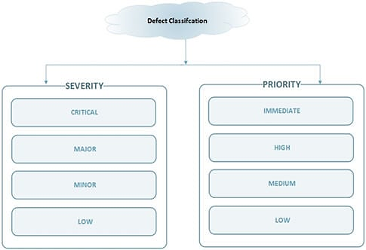

Image (3-1): Defect Classification

**<Instagram website> - Enhancement Request Form #1**

**Enhancement Header:**

|  |  |
| --- | --- |
| Date | 2023-05-20 |
| Enhancement # | 001 |
| Application Name-Screen Name | Instagram website – Laptop screen |
| Screenshots (Y/N) | Y |
| Submitted by | BAHA-AD-DIN AKOUR |
| Reproducible (Y/N) | Y |
| Reference | None |
| Software Version | 300.1 |
| Severity | Low |
| Priority | Low |

**Enhancement Description:**

* 1. **Module name - Improved user interface design to suit large screens.**
  2. **Steps followed.**

1. user opens Instagram website from his pc.
2. The design is more suitable for mobile devices.
   1. **Desired Results**

Design for the website Instagram more effectively.

Actual Results:  
Exploiting the screen and changing the design of the elements to improve the user experience of the website.

Screen shots:

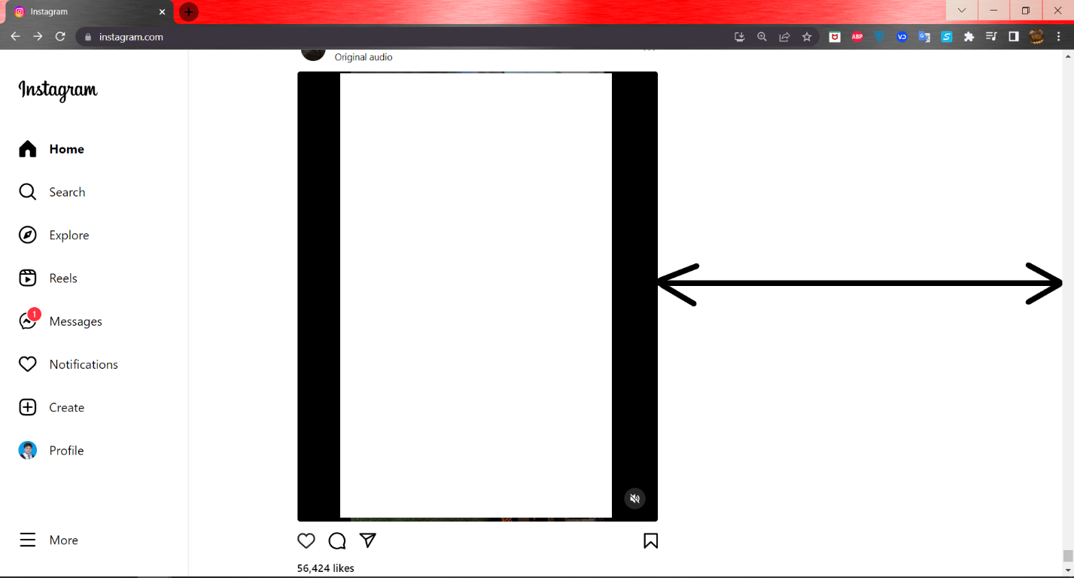

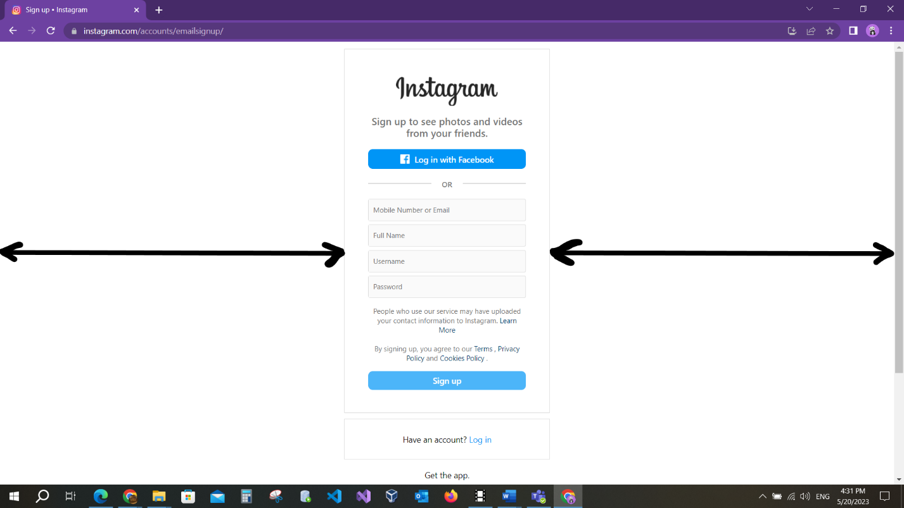

**<Instagram website> - Enhancement Request Form #2**

**Enhancement Header:**

|  |  |
| --- | --- |
| Date | 2023-05-20 |
| Enhancement # | 002 |
| Application Name-Screen Name | Instagram website – Laptop screen |
| Screenshots (Y/N) | Y |
| Submitted by | BAHA-AD-DIN AKOUR |
| Reproducible (Y/N) | Y |
| Reference | None |
| Software Version | 300.1 |
| Severity | Low |
| Priority | Low |

**Enhancement Description:**

**Module name – Add the Arabic language.**

**Steps followed.**

1. open Instagram website.
2. The Arabic language is not on the languages list.

**Desired Results**

When the user wants to change the language of the website, he will find the Arabic language in the options.

Actual Results: Add the Arabic language option to the languages list.

Screen shot:

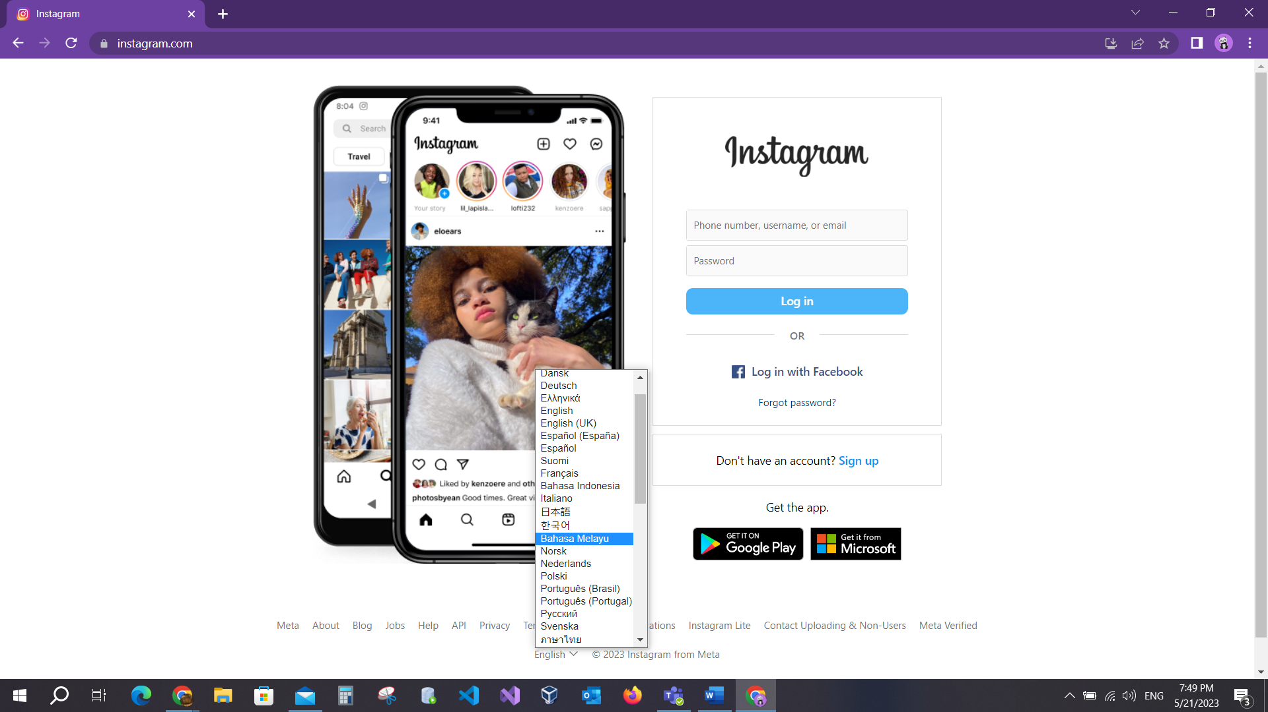

**<Instagram Website> - Supporting document for Defect #1**

***Defect Header:***

|  |  |
| --- | --- |
| Date | 2023-03-23 |
| Defect # | 001 |
| Application Name-Screen Name | Instagram website – Laptop screen |
| Screenshots (Y/N) | Y |
| Submitted by | BAHA-AD-DIN AKOUR |
| Reproducible (Y/N) | Y |
| Reference | None |
| Date | 2023-03-23 |
| Software Version | 300.1 |
| Severity | low |
| Priority | low |

***Defect Description:***

**Module name – Logo don’t redirect to main page.**

**Steps followed.**

1. Sign up page.
2. Click on Instagram logo.

**Desired Results**

The user should open the main page when clicking on logo.

Actual Results:



Click on the logo and redirect to www.instagram.com.

Screen shot:

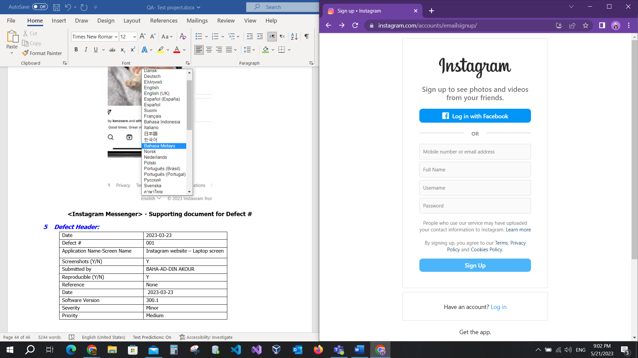



**<Instagram website> - Supporting document for Defect #2**

***Defect Header:***

|  |  |
| --- | --- |
| Date | 2023-05-22 |
| Defect # | 002 |
| Application Name-Screen Name | Instagram website – Laptop screen |
| Screenshots (Y/N) | Y |
| Submitted by | BAHA-AD-DIN AKOUR |
| Reproducible (Y/N) | Y |
| Reference | None |
| Date | 2023-05-22 |
| Software Version | 300.1 |
| Severity | Major |
| Priority | High |

***Defect Description:***

**Module name – Receiving inputs in the correct form.**

**Steps followed.**

1. Sign up page.
2. Fill not correct form phone or email.

**Desired Results**

When user entered email or phone number not correct display error msg.

Actual Results:



If user entered not correct email or phone format, the error msg is shown.

***Screen shot:***

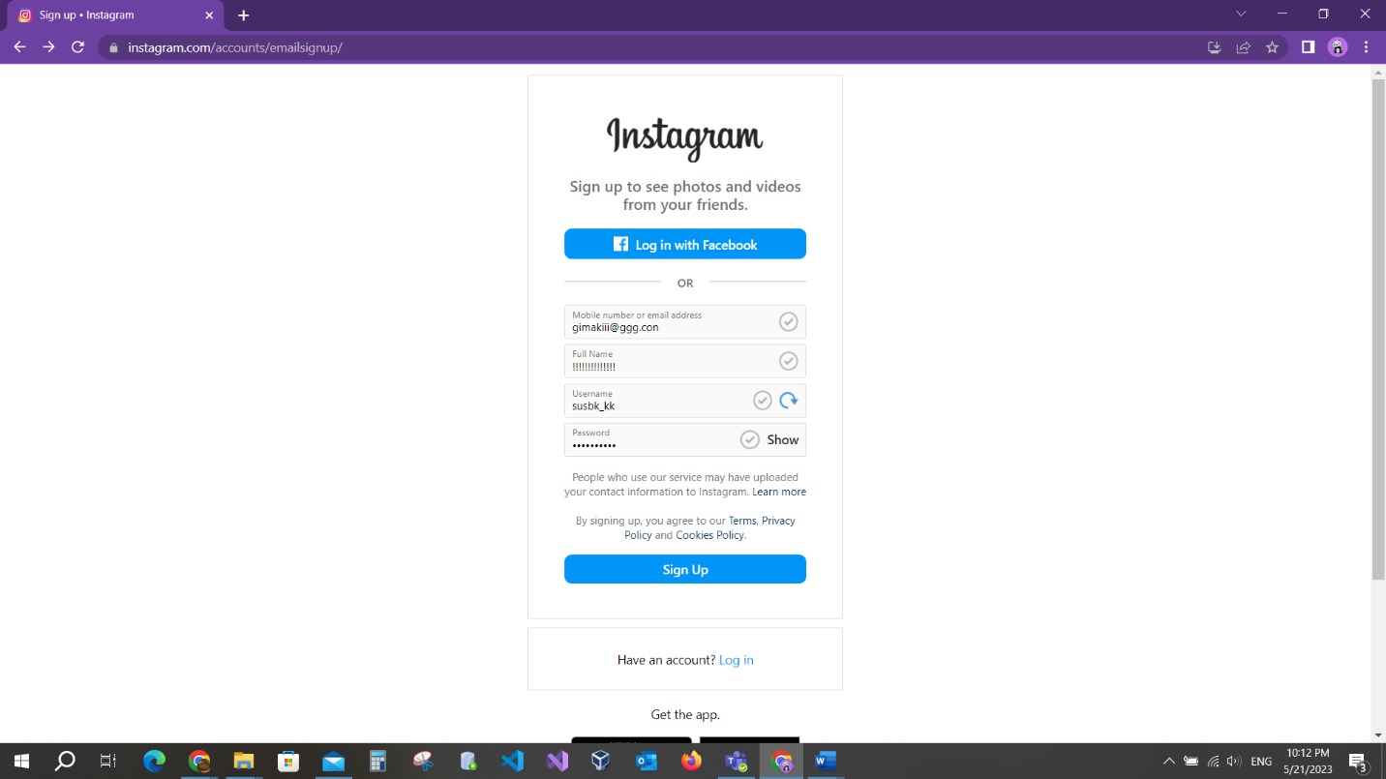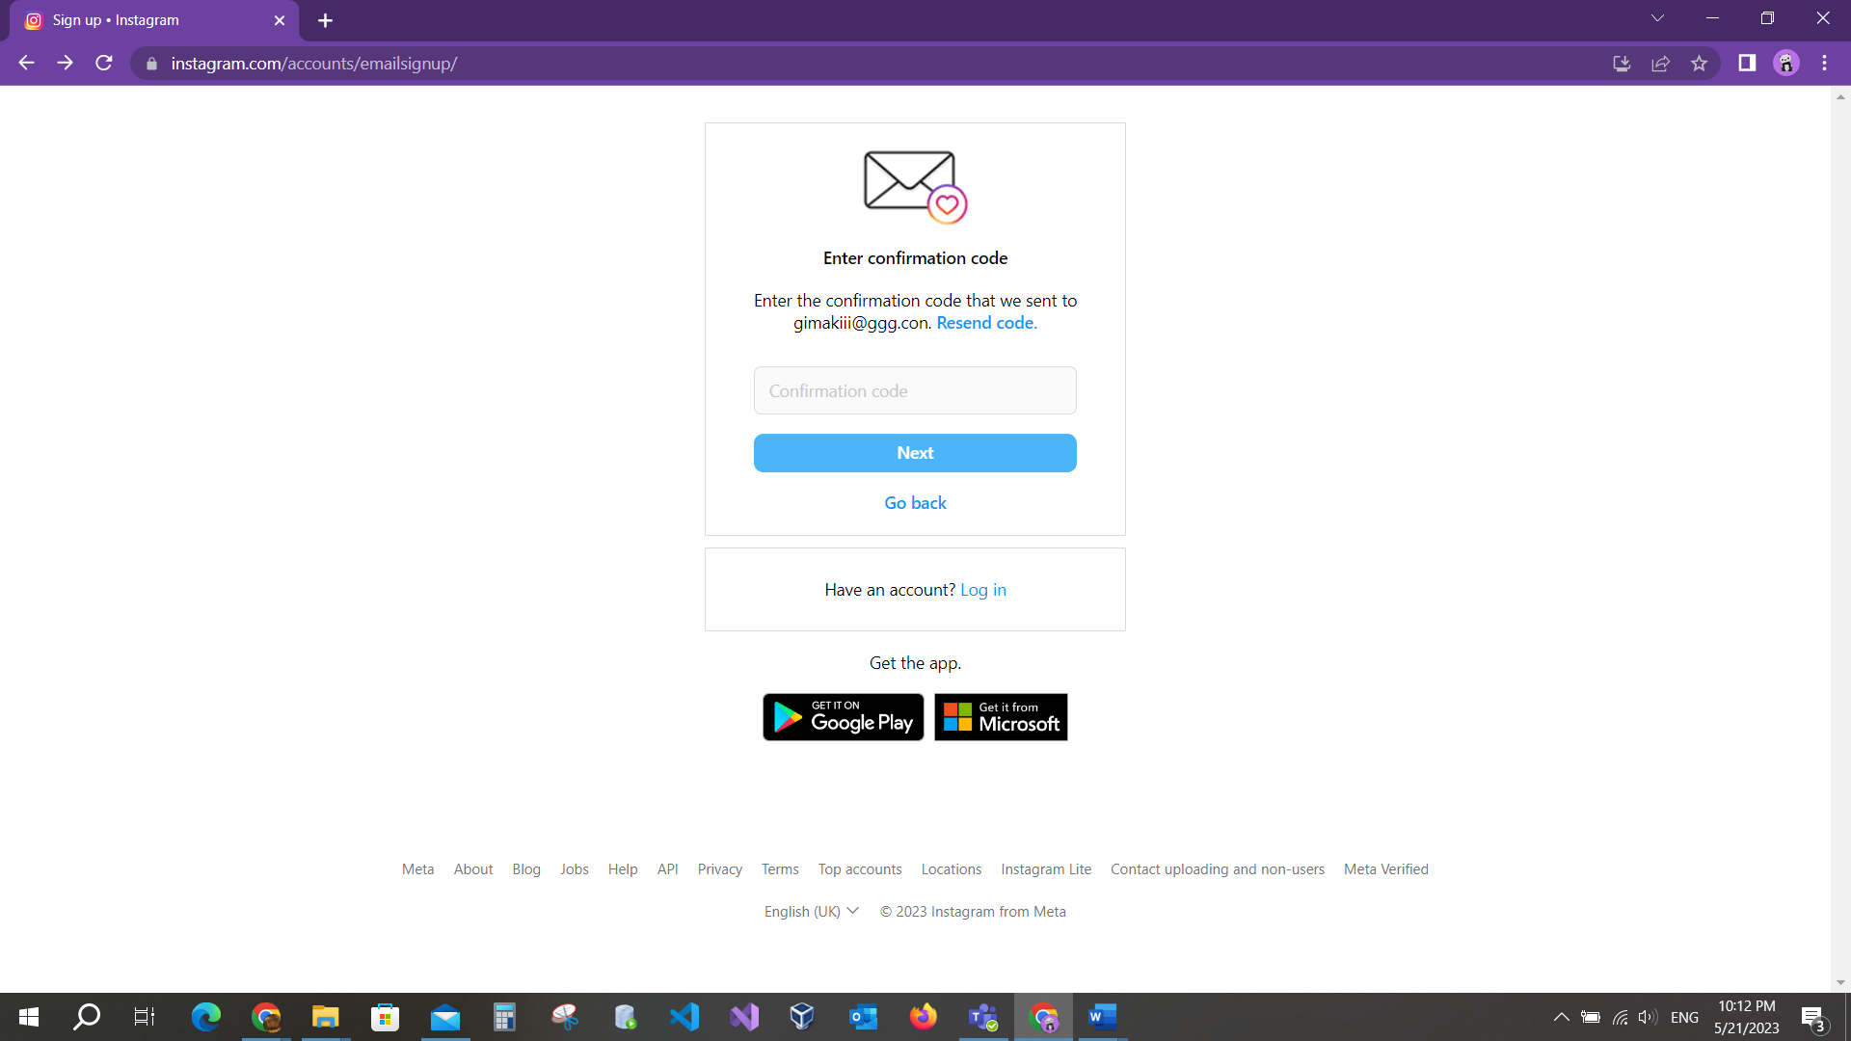

**<Instagram website> - Supporting document for Defect #3.**

***Defect Header:***

|  |  |
| --- | --- |
| Date | 2023-05-22 |
| Defect # | 001 |
| Application Name-Screen Name | Instagram website – Laptop screen |
| Screenshots (Y/N) | Y |
| Submitted by | BAHA-AD-DIN AKOUR |
| Reproducible (Y/N) | Y |
| Reference | None |
| Date | 2023-05-22 |
| Software Version | 300.1 |
| Severity | Major |
| Priority | High |

***Defect Description:***

**Module name – Add the roles for strongest password.**

**Steps followed.**

1. Sign up page.
2. Fill correct data in the fields.
3. Fill password.

**Desired Results**

When user enters a password that is not strongest password, the msg of write password roles displayed.

Actual Results:



If the user entered not correct password, the msg is shown.

***Screen shot:***

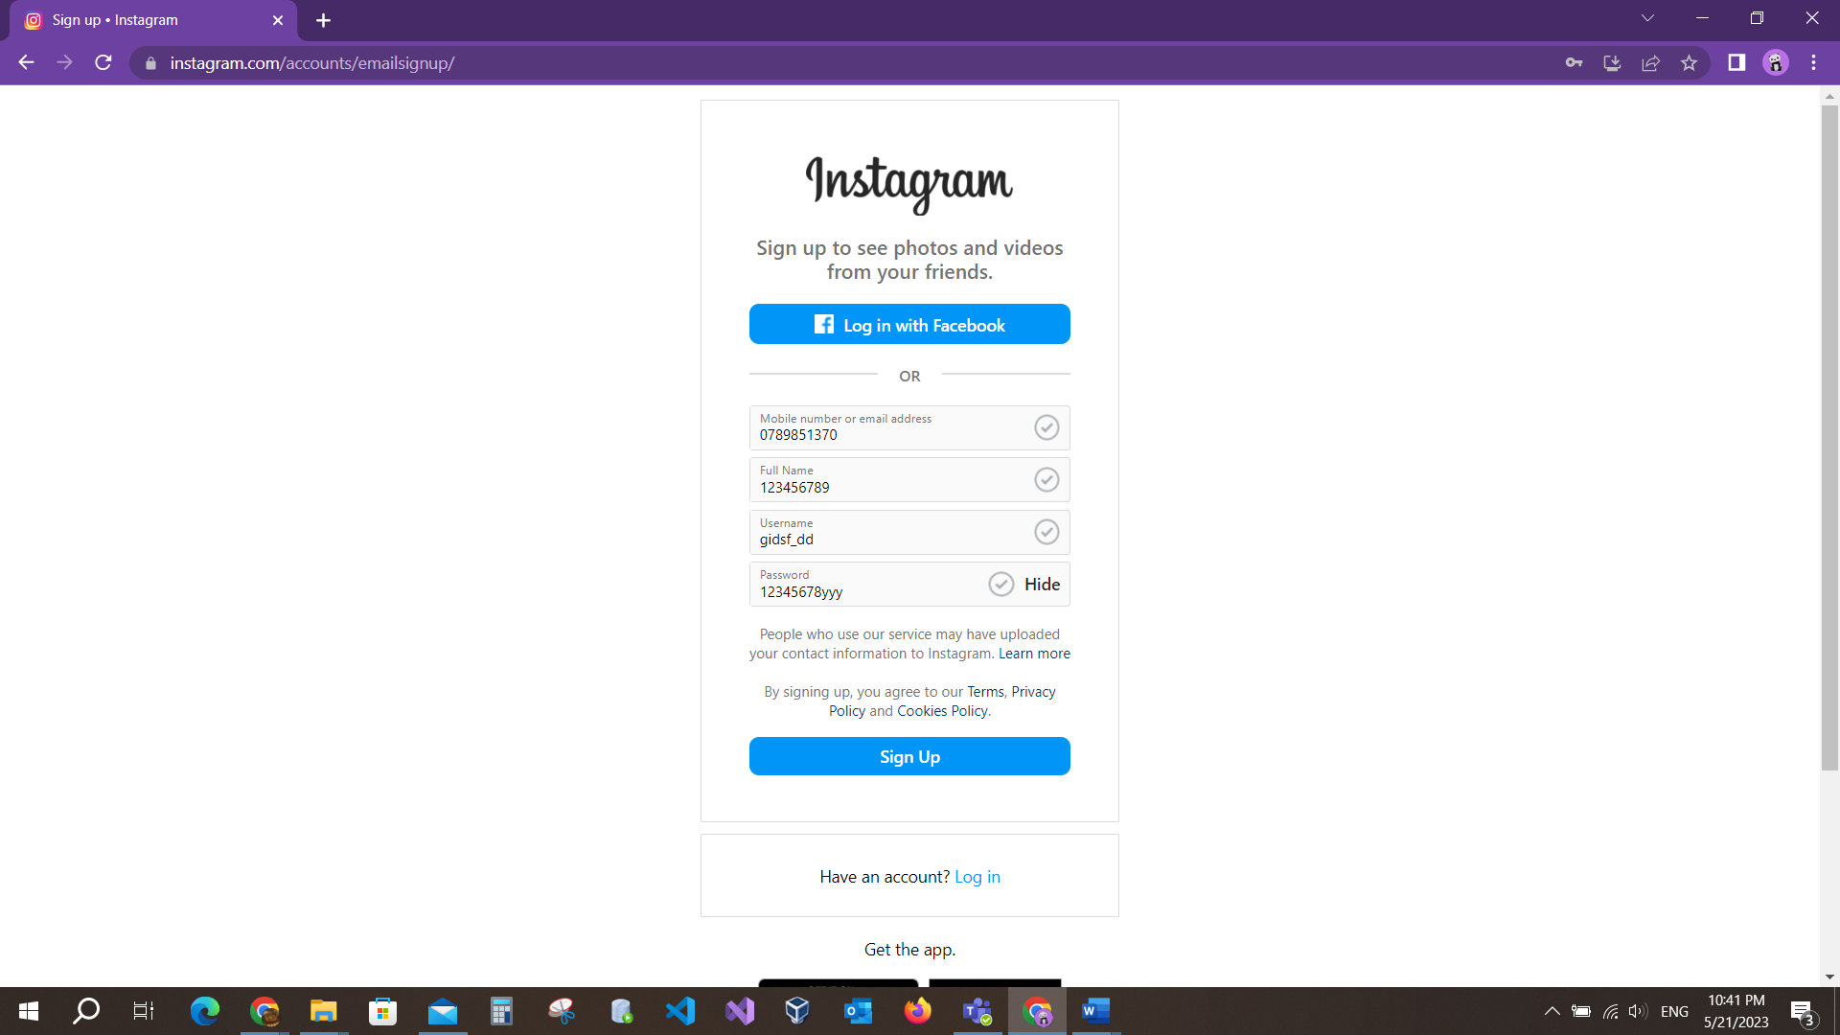



**This deficit is related for all Test cases for this Field.**

**<Instagram website> - Supporting document for Defect #4**

***Defect Header:***

|  |  |
| --- | --- |
| Date | 2023-05-22 |
| Defect # | 001 |
| Application Name-Screen Name | Instagram website – Laptop screen |
| Screenshots (Y/N) | Y |
| Submitted by | BAHA-AD-DIN AKOUR |
| Reproducible (Y/N) | Y |
| Reference | None |
| Date | 2023-05-22 |
| Software Version | 300.1 |
| Severity | Major |
| Priority | High |

***Defect Description:***

**Module name – The msg authentication number isn’t sent to Phone when user forgot password and fill field phone number.**

**Steps followed.**

1. Forgot password page.
2. Fill in the field phone number.

**Desired Results**

User fills his phone number relate the username the msg send to phone.

Actual Results:



Msg send to phone for user to account recovery.

**<Instagram website> - Supporting document for Defect #5**

***Defect Header:***

|  |  |
| --- | --- |
| Date | 2023-05-22 |
| Defect # | 005 |
| Application Name-Screen Name | Instagram website – Laptop screen |
| Screenshots (Y/N) | N |
| Submitted by | BAHA-AD-DIN AKOUR |
| Reproducible (Y/N) | Y |
| Reference | None |
| Date | 2023-05-22 |
| Software Version | 300.1 |
| Severity | Major |
| Priority | High |

***Defect Description:***

**Module name – Edit the photo after posted.**

**Steps followed.**

1. Create option to create post.
2. Edit the post.

**Desired Results**

Users edit the photo after posting it.

Actual Results:



message sent to the phone for the user's account recovery.

After I am done with defect tracking, I will add bugs to the Jira software..

**CHAPTER FOUR: TEST SUMMARY REPORTS**

* 1. Project Overview

The project is the website Instagram where I test some pages and track the defects. The website Instagram many pages and details. I may choose which pages are important to the user's browser of the site. During my execution of test cases I discovered some things such as authentication over the phone is done by the telecommunications company, where if there is a malfunction in sending the message consisting of 6 numbers, it is sent via the phone number of one of the telecommunications companies. I also discovered that there are some illogical things on some pages, and I wrote a report for improvement. There are many details on the Instagram site. I have satisfied myself with some pages that I found important to me.

* 1. Objective

The objectives are summarized as follows:

1. Test cases execution done.
2. Test Cases Statistics, the main activity pages I tested it.
3. Bugs, Defects and Enhancements Statistics.
4. Graph the metrics, shows Statistics in graph.

4.3 Statistics of the test cases

|  |  |  |  |
| --- | --- | --- | --- |
| 1 | Test Case ID | Execution Results | Scenario Type |
| Sign up page | 001 | Pass | Positive |
| 002 | Fail | Positive |
| 003 | Pass | Positive |
| 004 | Fail | Negative |
| 005 | Fail | Negative |
| 006 | Fail | Negative |
| 007 | Fail | Negative |
| 008 | Pass | Positive |
| 009 | Pass | Negative |
| 010 | Pass | Negative |
| 011 | Fail | Positive |
| 012 | Fail | Positive |
| 013 | Fail | Positive |
| 014 | Fail | Positive |
| 015 | Fail | Positive |
| 016 | Pass | Negative |
| 017 | Pass | Positive |
| 018 | Fail | Positive |
|  | Count of Test cases: 18, Pass:7, Fail:11 | | |

|  |  |  |  |
| --- | --- | --- | --- |
| 2 | Test Case ID | Execution Results | Scenario Type |
| Log in page | 001 | Fail | Positive |
| 002 | Pass | Negative |
| 003 | Pass | Negative |
| 004 | Pass | Negative |
| 005 | Pass | Negative |
| 006 | Pass | Negative |
| 007 | Pass | Negative |
| 008 | Pass | Negative |
| 009 | Pass | Negative |
| 010 | Pass | Positive |
| 011 | Pass | Positive |
|  | Count of Test Cases: 11, Pass:10, Fail:1 | | |

|  |  |  |  |
| --- | --- | --- | --- |
| 3 | Test Case ID | Execution Results | Scenario Type |
| Forgot password page | 001 | Fail | Positive |
| 002 | Fail | Positive |
| 003 | Pass | Positive |
| 004 | Pass | Negative |
| 005 | Pass | Negative |
| 006 | Pass | Negative |
|  | Count of Test Cases: 6, Pass:4, Fail:2 | | |

|  |  |  |  |
| --- | --- | --- | --- |
| 4 | Test Case ID | Execution Results | Scenario Type |
| Home page | 001 | Pass | Positive |
| 002 | Pass | Positive |
| 003 | Pass | Positive |
| 004 | Pass | Positive |
| 005 | Pass | Positive |
| 006 | Pass | Positive |
|  | Count of Test Cases: 6, Pass:6 , Fail:0 | | |

|  |  |  |  |
| --- | --- | --- | --- |
| 5 | Test Case ID | Execution Results | Scenario Type |
| User profile page | 001 | Pass | Positive |
| 002 | Pass | Positive |
| 003 | Pass | Positive |
|  | Count of Test cases: 3, Pass:3, Fail:0 | | |

|  |  |  |  |
| --- | --- | --- | --- |
| 6 | Test Case ID | Execution Results | Scenario Type |
| Posting | 001 | Pass | Positive |
| 002 | Fail | Positive |
| 003 | Pass | Positive |
|  | Count of Test cases: 3, Pass:2, Fail:1 | | |

* 1. Statistics of the Bugs
* Enhancements: 2
* Defects: 4
  1. graph

Test cases:

Graph (1): Test cases

**CHAPTER FIVE: CONCLUSION**

Through my quality assurance project, I have gained valuable insights into the inner workings of the Instagram website and identified several areas where it could be improved for better user experience. I am confident that the feedback and recommendations I have provided will help the development team at Instagram continue to optimize and refine the website for years to come.

At the same time, I recognize that the Instagram website is already a powerful and effective tool for social connection and creative expression, and I am proud to have played a role quality assurance.

REFERENCES:

1. https://strongqa.com/qa-portal/testing-docs-templates/test-plan
2. https://www.codingninjas.com/codestudio/library/software-testing-and-principles-of-testing
3. https://web.dev/responsive-web-design-basics/
4. https://marker.io/blog/how-to-write-bug-report
5. “According to OpenAI's AI language model, ChatGPT”, which includes a wide range of sources up until September 2021.
6. https://www.apriorit.com/qa-blog/197-testing-time-estimation
7. https://www.softwaretestinghelp.com/how-to-set-defect-priority-and-severity-with-defect-triage-process/
8. https://www.softwaretestinghelp.com/when-to-stop-testing-exit-criteria-in-software-testing/